Campus Event & Venue Management System Business Case

Introduction
The purpose of this business case is to outline the proposed development of the Campus Event and Venue Management System, initially focusing on the Nelson Mandela University Conference Centre. The document establishes the context and justification for the project and provides a basis for planning its development.
The business case covers the problem domain, project objectives, and background research relevant to event and venue management. It also examines related software systems to identify features and approaches that may inform the proposed solution. In addition, the document presents the project plan, including the planned deliverables, milestones, responsibilities and development timeframe, followed by a risk analysis identifying factors that may affect the successful completion of the project.
The initial scope is limited to the Conference Centre to ensure that the project remains focused and achievable within the available development period.

1.1 Fragmented Conference Centre Venue Booking and Information
Organising an event at Nelson Mandela University (NMU) requires organisers to identify a venue that meets their needs in terms of availability, capacity, location and facilities. The initial focus of this project is the Conference Centre, where both internal university users and external organisations may require venues for events.
Preliminary investigation indicates that different booking approaches are used depending on the type of organiser. Internal users can submit requests through a staff portal and booking form, while external organisations primarily make enquiries through telephone calls and email. As a result, external organisers do not have a straightforward way to view venue availability and may enquire about venues that are already booked.
Determining availability can also require additional communication. Staff handling an enquiry may need to contact another office or person to confirm whether a venue is available. External organisers may therefore have to wait for information before they can proceed with their event planning. Telephone communication can create further difficulties when lines are unavailable, requiring organisers to use email instead.
Another challenge is the accessibility of venue information. External organisers may know about a particular venue through previous events or recommendations but may have limited knowledge of alternative venues. Information such as capacity, location, parking and available facilities is important when selecting an appropriate venue. Without easily accessible information about available alternatives, organisers may repeatedly enquire about venues they already know.
The current approach can also create repetitive administrative work. Staff may receive multiple telephone calls and emails requesting information about the same venue, while organisers may need to make additional enquiries when information was not provided during the initial communication. Important booking and venue information is therefore distributed across different communication channels and, in some cases, requires communication between university offices.
These challenges affect both event organisers and Conference Centre staff. Organisers may spend additional time identifying suitable venues and obtaining availability and venue information, while staff spend time responding to enquiries and confirming information. The problem addressed by this project is therefore the difficulty of efficiently accessing, communicating and managing venue information and booking requests during the Conference Centre's event planning process.
1.2 Project Objectives
The project aims to improve the efficiency and accessibility of the Conference Centre's venue booking and information processes. The system will:
- Centralise venue information by providing organisers with details such as venue capacity, location, facilities, parking and available equipment.
- Improve visibility of venue availability by providing users and authorised staff with up-to-date information about venue bookings and available time slots.
- Streamline booking requests by providing a structured digital process for submitting and monitoring venue booking requests.
- Assist organisers in finding suitable venues by allowing them to search and filter venues according to requirements such as capacity, facilities and availability.
- Provide centralised administrative management for authorised staff to maintain venue information and manage booking requests.
- Improve booking communication by providing organisers with booking status updates and relevant notifications.
- Reduce unnecessary administrative enquiries by making commonly requested venue and booking information accessible through the system.
1.3 Problem Background
Universities manage shared venues for a wide range of activities, including lectures, conferences, workshops, seminars, research presentations and student events. Venue management requires consideration of factors such as date, time, capacity, location, facilities and event requirements. Since multiple users may require the same spaces, accurate availability information and an organised booking process are important for effective use of university facilities.
Research has identified challenges associated with traditional and fragmented venue-booking processes. Heera et al. (2025) examined a campus venue-booking process and identified difficulties related to obtaining up-to-date venue information, communication and conflicting bookings. Their proposed system incorporated venue information, real-time availability and online booking functionality, demonstrating how centralised information can support more efficient venue management.
Similar approaches have been explored in other university environments. Khamaruzaman et al. (2025) investigated a digital space-booking solution for architecture schools at Universiti Teknologi MARA. The proposed system included features such as a visual booking calendar, real-time room availability and automated booking confirmations. These features were intended to improve space planning, reduce booking conflicts and assist users in selecting suitable spaces.
Nelson Mandela University (NMU) already provides some digital venue information. Its online venue timetable provides information about scheduled activities and venue details, including capacity (Nelson Mandela University, 2026). The university has also published information about venues available for external use, including venue capacities and rates (Nelson Mandela University, n.d.). These resources show that venue information is already available digitally, but information provision and booking management are separate aspects of the overall process.
Existing commercial scheduling systems demonstrate how these activities can be integrated. For example, 25Live provides tools for event and space scheduling, including availability checking, booking requests, approval workflows, resource management, calendar publishing and reporting (CollegeNET, n.d.). Such systems demonstrate that venue management can extend beyond displaying schedules to supporting the different stages of a booking process.
Overall, the literature indicates that effective venue-management systems can benefit from centralised venue information, availability visibility, structured booking processes and administrative controls. These findings provide a basis for investigating how similar principles could be applied to the NMU Conference Centre while taking into account its specific requirements and existing processes.
1.4 Related Systems Analysis
Existing venue and space-management systems were reviewed to identify approaches that could inform the development of DIBA Bookings. The systems selected demonstrate different approaches to venue discovery, availability management, booking and physical-space navigation.

1.4.1 Booking.com
Platform: Web-based
Description:
Booking.com is a web-based accommodation booking platform that allows users to search for accommodation based on criteria such as location, dates, number of guests and property type. Users can compare available options, view detailed information about properties, check prices and availability, and make reservations through the platform. The system provides a centralised interface that allows users to discover and compare options before making a booking decision.
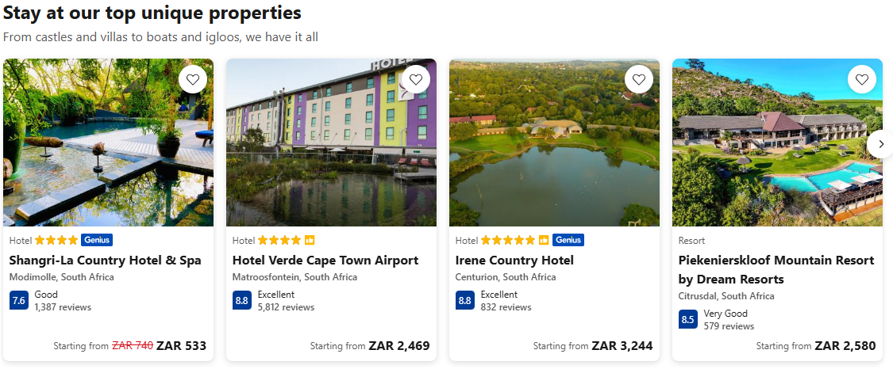
Figure 1: demonstrates how Booking.com presents different accommodation options, including images and key details, allowing users to compare available choices.
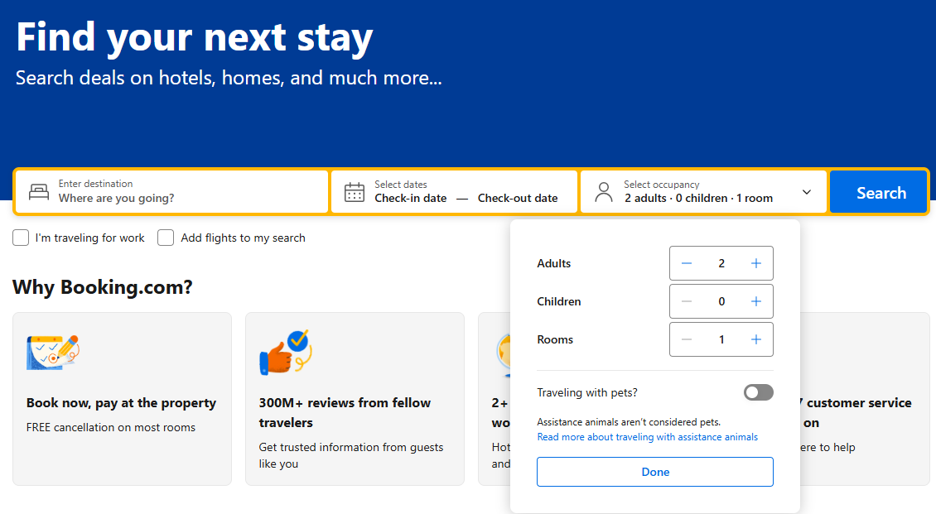
Figure 2: demonstrates the search and filtering functionality, which allows users to narrow available options according to their requirements.
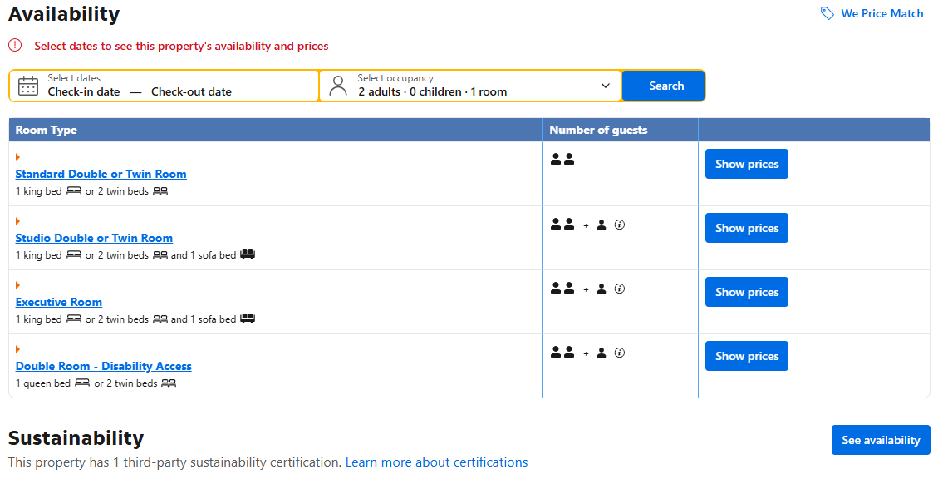
Figure 3: demonstrates how availability can be determined based on the user's selected dates.
Features/processes to adapt:
- Search and filtering of venues based on requirements such as capacity, date and facilities.
- Clear display of venue availability.
- Structured booking-request workflow.
- Role-based access for different types of users.
- Clear presentation of space information.
Features/processes to avoid:
- Excessively complex configuration that is unnecessary for a small initial implementation.
- Advanced enterprise scheduling functionality outside the project's scope.

1.4.2 LibCal Spaces
Platform: Web-based
Description:
LibCal Spaces is a space-reservation component of the LibCal platform developed by Springshare. It allows organisations to make physical spaces available for online discovery and reservation. Users can view available spaces, search according to requirements and submit reservations through the platform.
Figure 1.2: LibCal Spaces reservation interface.
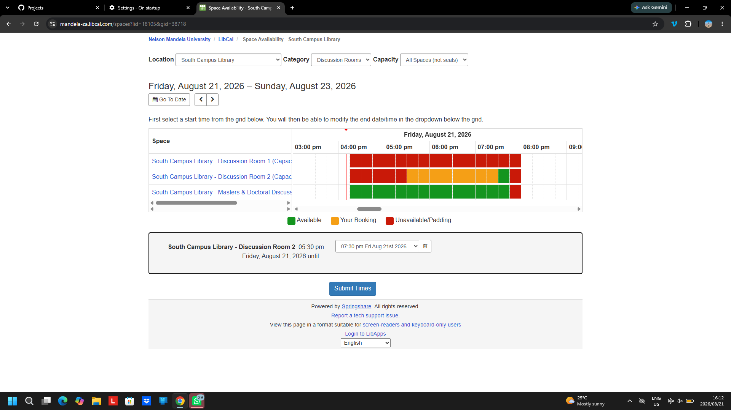
Figure 4: LibCal Spaces availability calendar displaying available and occupied time slots
Features/processes to adapt:
- Visual availability calendars.
- Online reservation requests.
Features/processes to avoid:
- Features primarily intended for library study spaces, such as individual-seat reservations.

1.4.3 Nelson Mandela University Virtual Tour
Platform: Web-based
Description:
Nelson Mandela University's virtual tour provides an interactive way for users to explore university campuses remotely. The tour provides a visual representation of campus locations and facilities and can help users become familiar with physical spaces before visiting them.
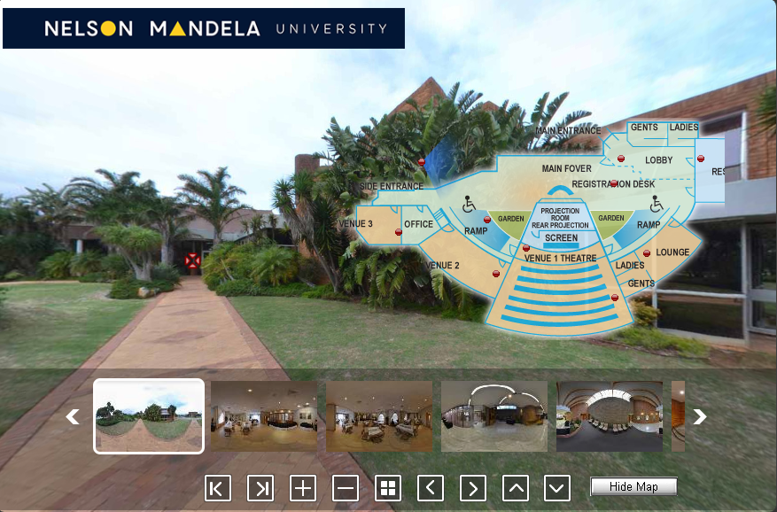
Figure 5: demonstrates the NMU Virtual Tour map, which provides users with a visual representation of campus locations and assists them in identifying where facilities are situated.
Features/processes to adapt:
- Interactive visual representation of venues.
- Location information to help users understand where a venue is situated.
Features/processes to avoid:
- Treating the virtual tour as a standalone discovery tool without connecting it to the booking process.
- Including extensive campus-tour functionality that is unrelated to venue booking.

1.5 The Project Plan
Table 1: Project overview
Item | Details
Project name | DIBA Bookings – Campus Venue and Event Management System
Proposed client/domain | Nelson Mandela University Conference Centre
Project team | Ntlahla and Sena
Project manager | Ntlahla
Project duration | 11 weeks
Development approach | Iterative development

Table 2: Stakeholders and their responsibility
Stakeholder | Responsibility
Conference Centre staff | manage venues and booking requests
Internal university users | staff, departments and student organisations requiring venues.
External event organisers | users who may request Conference Centre facilities.
Project team | responsible for analysing, designing and developing the system.
Project lecturer/supervisor | provides academic guidance and feedback.

Activity / Deliverable | Dependency
Requirements analysis | Preliminary investigation and problem definition
System design | Completed requirements analysis
Database design | Requirements analysis and system design
User interface design | Requirements analysis and system design
User authentication & role-based access | Database design and system design
Venue information management | Database design
Venue availability management | Venue database and booking structure
Venue search & filtering | Venue information and database structure
Event management | Database design and requirements
Booking request & approval | User, venue and event functionality
Notifications & booking status | Booking workflow
Administrative management | User roles, venue and booking functionality
Reporting | Completed booking and event data
System integration | Core modules completed
Testing | Integrated and functional system
User documentation | Stable system and user workflows
Source code/version control | Begins with development and continues throughout project
Final deployment/presentation | Testing and final corrections completed
Table 3: Project deliverables and Dependencies

Gantt Chart

Diba Bookings Project start: _{Fri, 7/31/2026}
DB Devs, Ltd. Project lead Display week: 1
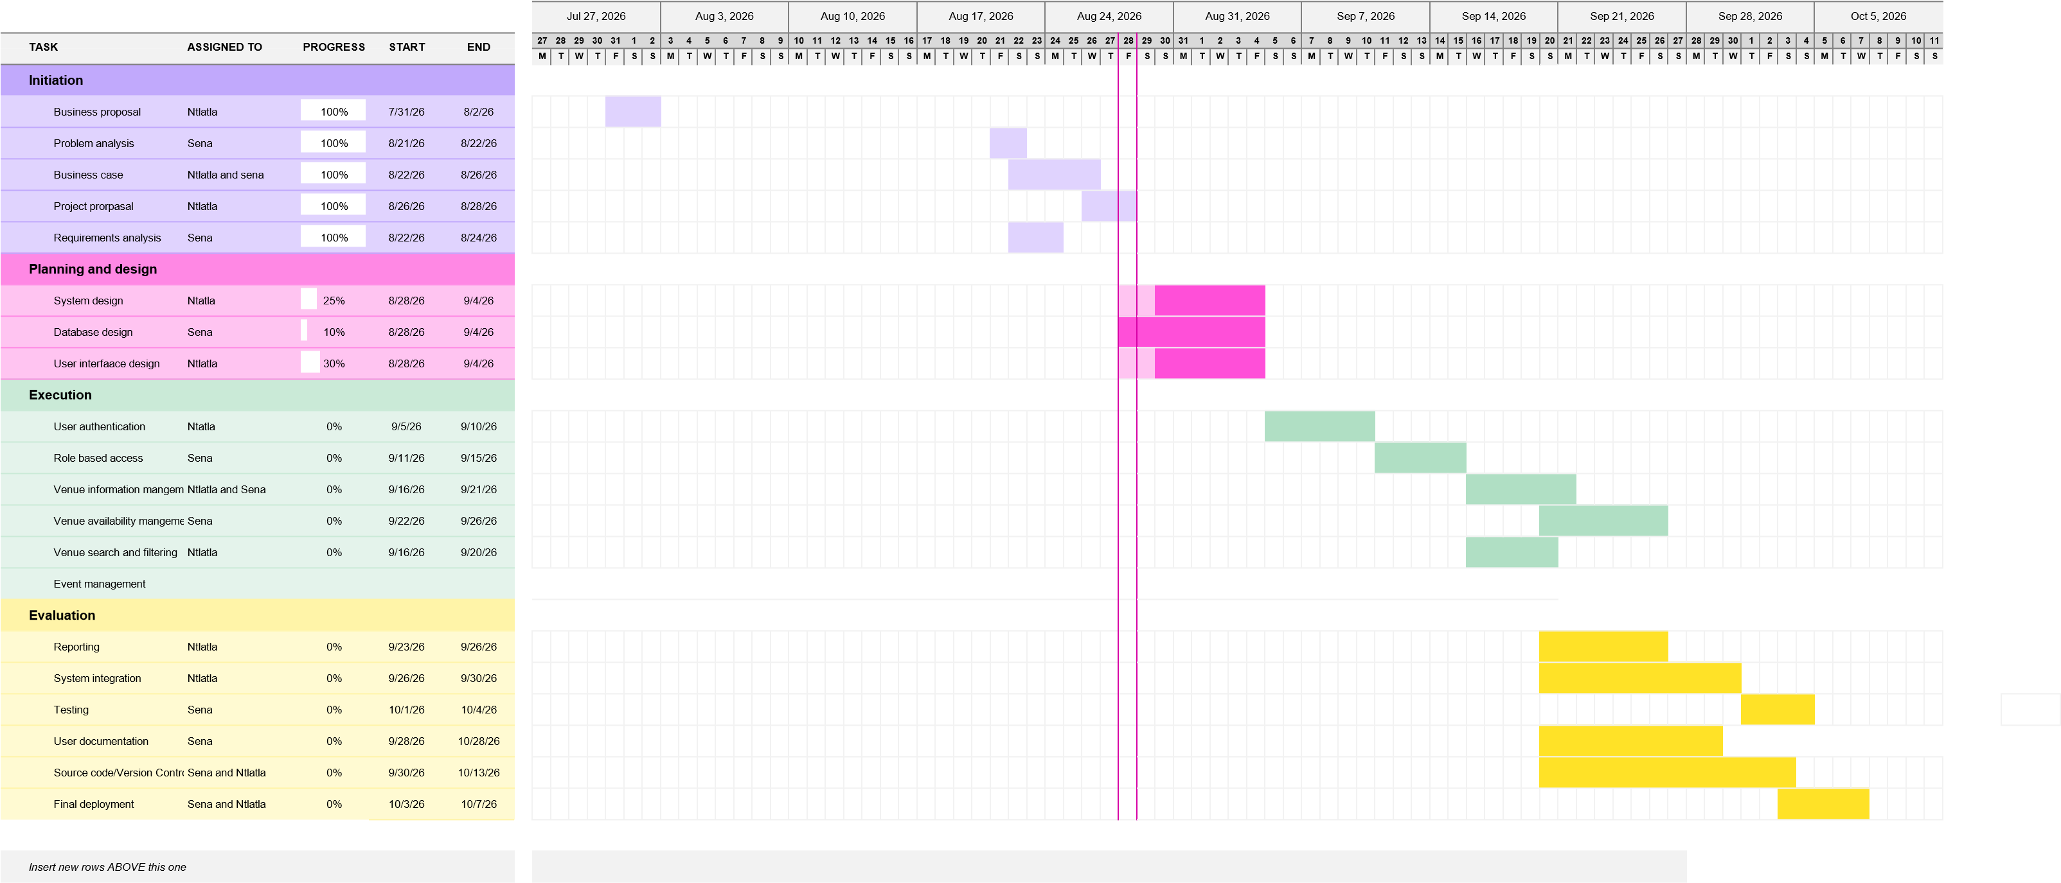

1.6 Risk Analysis
The project may be affected by several risks relating to stakeholder availability, project scope, development time and security. These risks have been considered so that appropriate actions can be taken to reduce their likelihood or impact.
Table 4: Project risk analysis
Risk | Type | Likelihood | Impact | Treatment
Limited stakeholder availability and feedback | Minimizable | High | High | Continue development using preliminary investigation, existing university information, literature and related-system research. Attempt to obtain stakeholder feedback where possible and incorporate it into later iterations.
Project scope becoming too large | Avoidable | High | High | Initially limit the system to the Conference Centre. Prioritise essential booking functionality and only add other venues or optional features if sufficient time remains.
Insufficient development time | Minimizable | High | High | Use weekly milestones, prioritise core functionality and begin development early. Optional features will be reduced or postponed if the project falls behind schedule.
Security vulnerabilities | Minimizable | Medium | High | Implement authentication, role-based access, input validation and appropriate database security. Security will be considered throughout development and included in system testing.

References
CollegeNET. (n.d.). 25Live: Event and space scheduling software for universities. https://collegenet.com/scheduling/25live
Heera, R. S., Surya, S., & Arunkumar, P. (2025). Campus venue booking. International Research Journal of Engineering Design and Technology, 7(3).
Khamaruzaman, [verify author details], et al. (2025). Smart space: A booking solution for architecture schools. Universiti Teknologi MARA Institutional Repository.
Nelson Mandela University. (2026). Venue lecture timetable. Nelson Mandela University.
Nelson Mandela University. (n.d.). Function facilities (external usage) [PDF].

